**Lab Research Data Analyst Portfolios**

Part 1 Research Data Analyst Portfolios

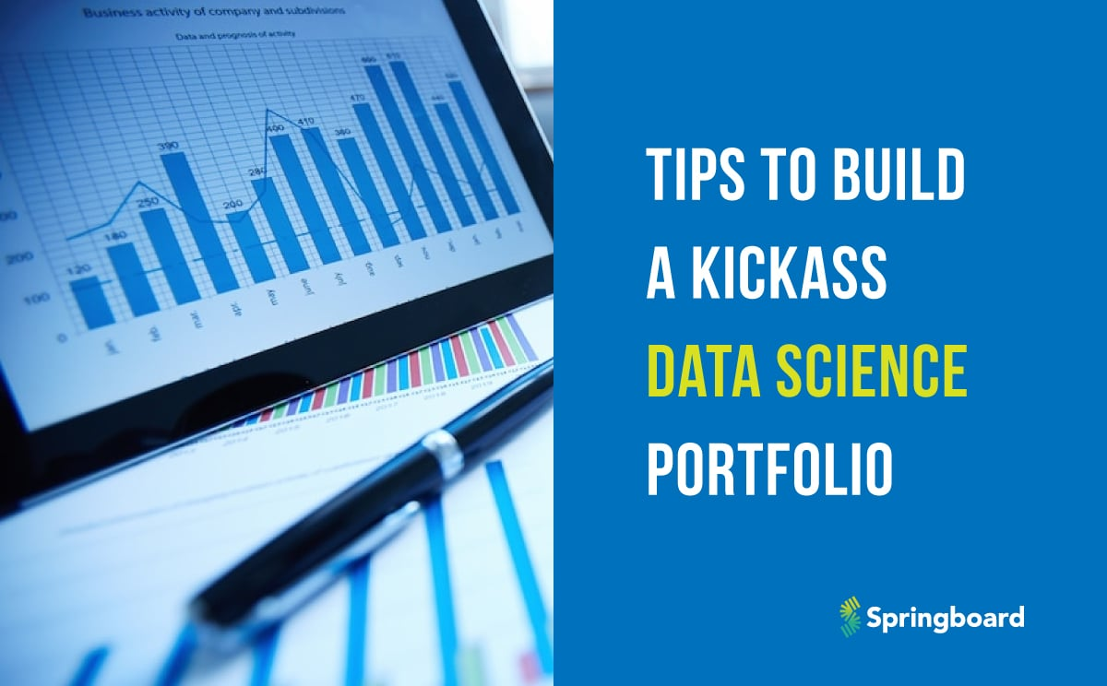

A Data Science portfolio should include projects you have done, what have you learnt from this project, what Softwares did you use, and what title face should we use to make it eye catching for the reader to read.

What is the purpose of having a data analytics portfolio?

To showcase my work and projects that I did on the Just IT Bootcamp Programme in Data Technician. For example, I completed tasks on Excel and Marco, Public Tableau, Power BI, my SQL, Azure Softwares, Internet of Things, Python and R Studios.

If an employee reads my Portfolio of achievements and projects, they will say to me Wow, I did a Data Technician course to upskill and be competitive, when am applying for a job.

Claudia Ten Hoope’s portfolio project looks eye-catching because she included tabs with hyperlinks- Services, about me, Por, Portfolio, Contact, and NL page.

As a data scientist, she did a lot of Data Analytics, created Dashboards, and coached on projects, interactive infographics, and Front- end websites.

**Step2: List possible projects.**

1. Data Visualization- on Wealth of Nations – Tableau and Power BI

2. Manipulating and Cleaning Dataset in Tableau and Power BI

3. Customers Salary in My SQL Workbench.

I would like to pursue a career as a Data Technician, because throughout my recent training, learnt how to install Jupiter lab in Python, R Studio, manipulate data, and clean data both on Public Tableau and Power BI.

**Step 3 : Consider possiblfe portfolio styles:**

Step 4 Create a portfolio checklist

Completed Tasks

Excel and Tableau Assignment

Excel and Power BI

My SQL

Azure Database

Internet of things

R Studio

Assignments

Uncompleted Tasks

R Studio assignments

**Step 4 Data Analyst s**

A Data Analyst expert uses Microsoft Excel to build pivot tables and present relevant information.

Anyone who is willing to be a Data Analys would need to master those skills carefully to succeed in the job role such as statistics, clear communication, programming and numerical analysis as well/RF

**Reflection Questions**

Do you have any experience in Excel to become a successful Data Analysis?

How many times have you studied statistics in Excel?